**WEB APPLICATION USING NODE-RED SERVICE**

|  |  |
| --- | --- |
| **TEAM ID** | **PNT2022TMID53703** |
| **PROJECT NAME** | **IOT BASED SMART CROP PROTECTION SYSTEM FOR**  **AGRICULTURE** |

**STEP 1:** Click http://127.0.0.1:1880/#flow/29b7a8a83c697f0e to create the Web Application.

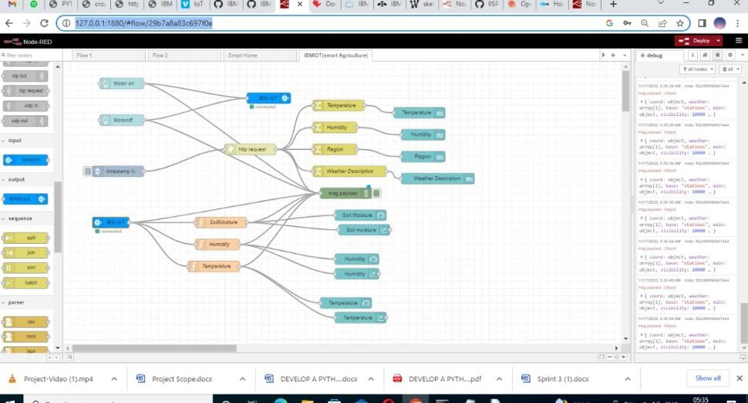

**STEP 2:** Click <https://kd5lkd.internetofthings.ibmcloud.com/>to see the output

